

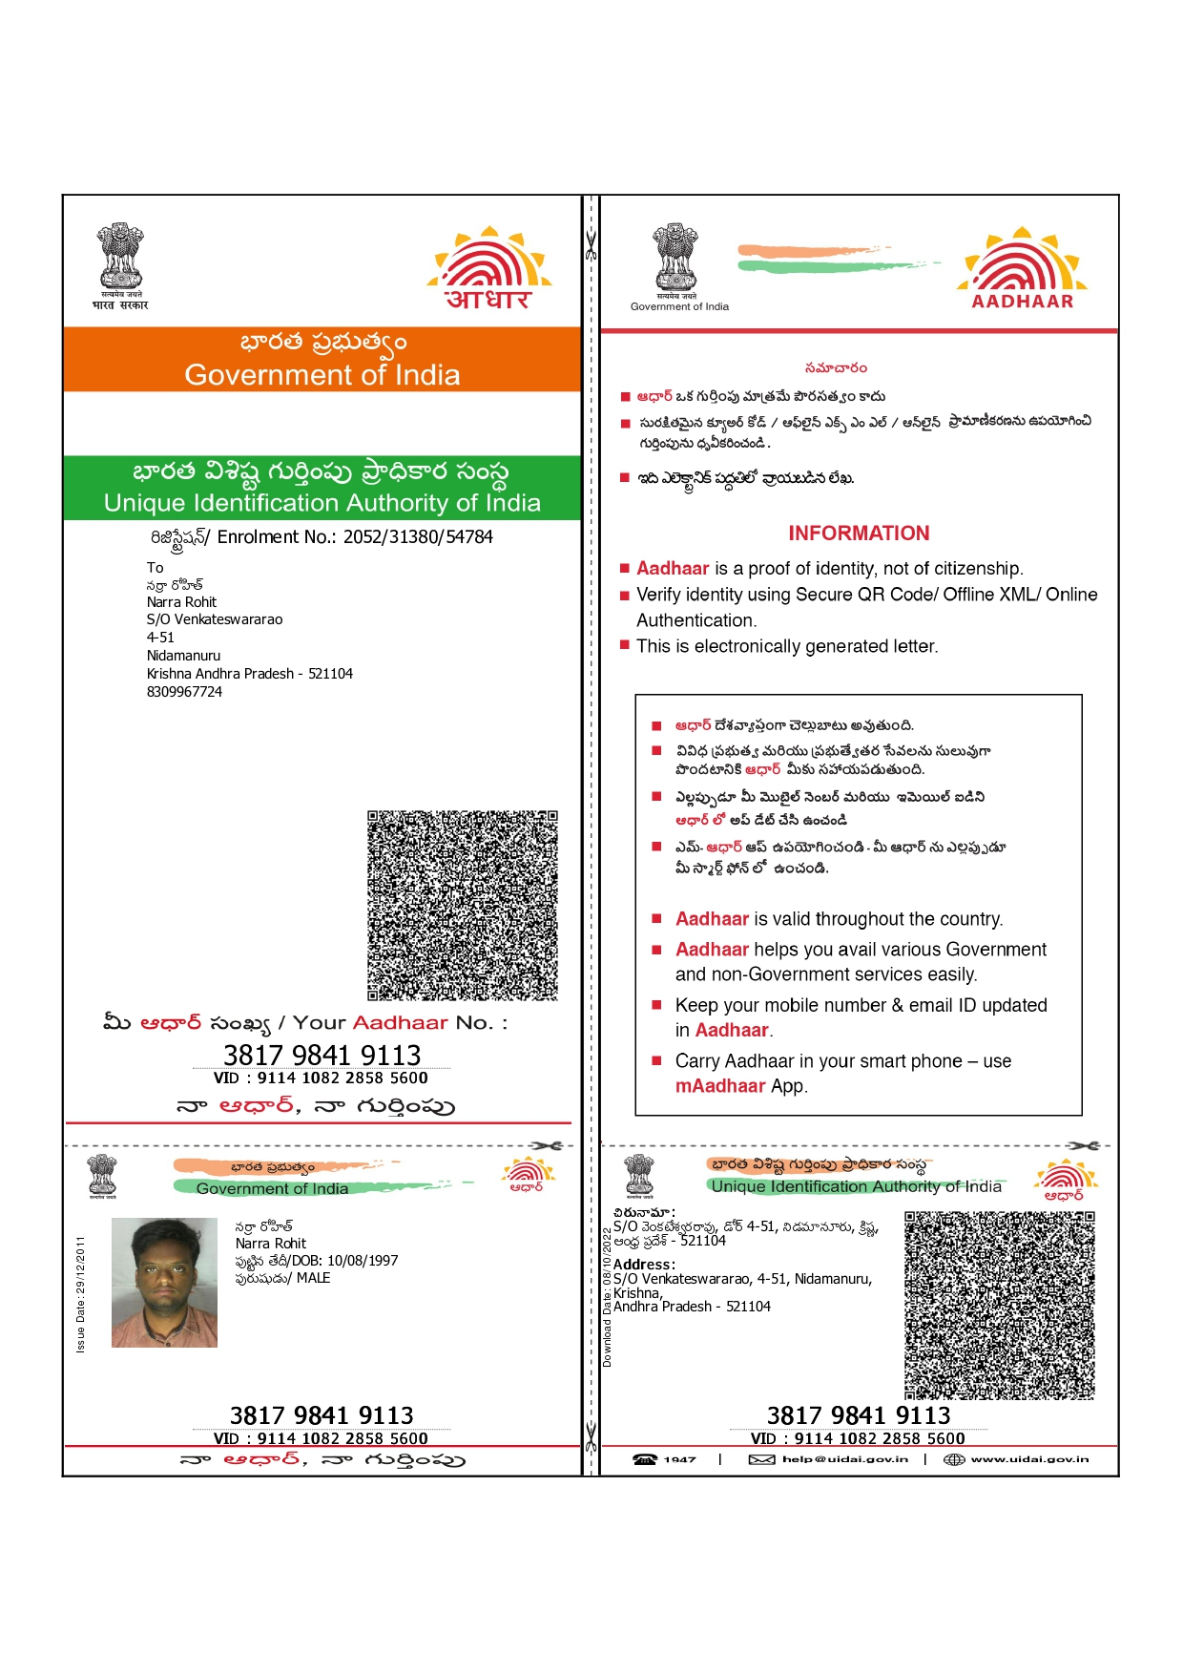

Video Link:- Rohit Narra_ Inteview _ Data Engineer(Python)-20230909_163136-Meeting Recording.mp4

ROHIT NARRA
(+91)- 917-709-7144 | rohitnarra2@gmail.com| www.linkedin.com/in/rohit-narra-vja

EDUCATION

Sathyabhama University, Chennai, India July 2015 – May 2019 Bachelor of Engineering in Computer Science
Related courses: Object Oriented Programming, Databases, Data Structures, Software Engineering, Machine learning.

TECHNICAL SKILLS
Programming Languages: Python, Java and Scala.
Data Processing: Spark/PySpark, Pandas and Apache Kafka.
Data Orchestration: Airflow/GCP cloud Composer.
Databases: Cassandra, SQL server and MySQL.
Storage Systems: AWS s3, Azure Blob Storage, GCP cloud storage and HDFS.
Cloud Technologies: Azure SQL Database, Azure Synapse analytics, Azure Data Factory, BigQuery, GCP Dataproc andCloud composer.
Frameworks: Flask and Spring boot.
Tools: Maven, Git, Docker, SonarQube, Yarn, AutoSys, Putty and FileZilla.
Certifications: Course training from BSNL on Core Networking and Mobile technologies, Azure developer associate,NPTEL Course certifications on Machine Learning and cloud Computing.

PROFESSIONAL EXPERIENCE

- Overall Tenure of 4 years of IT experience as a data engineer working on big data technologies and
designing datamodels in SQL and NoSQL databases.
- Experience even in MLOPS for creating workflows, having data checks and use machine learning metrics likedrift, PSI score for integration of ML models with Data.
- Exposure in working with various services of big data on Azure and GCP cloud platforms.
- Work exposure with Pyspark/spark using scala and java api’s in various projects for doing data transformations,ingestionto databases or Cloud storage systems and deploying through ci/cd pipelines.
- Building microservices with flask framework, automating data processing with python and deploying pythonapplications on cloud.
- Doing Exploratory data analytics for extracting insights from data and debugging or troubleshoot
issues with in adata pipelines.
- Designing the data pipelines to get data from multiple sources and process them to other sources.
- Building microservice based applications for data communication in between applications.

WORK EXPERIENCE
Fractal Analytics, Bangalore, India
Engineer (cloud and data tech) April 2022 – Present
Cognizant, Bangalore, India
Associate Software Engineer June 2019 – March 2022
Intern February 2019– May 2019
BSNL, Vijayawada
Intern Trainee on core networking and mobile technologies. November 2017 - December 2017

PROJECTS

PEP, Cognizant June 2019 – January 2021
Environment: Python, Pandas, Flask, Spark, Scala, Cassandra, Kafka, BitBucket and Devops.
- Developed data loaders with Spark and Scala for getting data from multiple sources like Kafka, parquet, JSON,SQL, Cassandra then doing data transformations and ingest it to the Cassandra.
- Building a customized classification algorithm for application classification based on the application data with
python and building api’s with Flask framework of python.
- Design the table schemas in Cassandra, deploying the code with ci/cd pipelines for various environments.
- Managing Environment configuration and integrating with application code.
- Writing unit test cases for python application code with pyunit and increasing new code coverage.

CARDS, Cognizant February 2021- March 2022
Environment: Spark, Java, SQL, Spring boot, Cucumber, Maven, Bitbucket and Devops.
- Migrating the data pipelines to the Spark architecture from old technology with Java and Spring boot
framework by supporting multiple data sources and writing the data to HDFS in parquet file format.
- Using spark sql module for doing data transformations with spark data frames, writing UDFs for
spark dataframes and deploying Code with ci/cd pipelines to testing environments.
- Analysis of old system sql scripts and mapping with new tables, changing sql queries accordingly.
- Writing unit test cases with cucumber to test data transformation by creating test data and deploying the code through ci/cd pipelines.

Api Integration, Fractal Analytics April 2022 – June 2022

Environment: Python, Flask, Webhooks, Restful api, Postman, Azure App Service, Azure Git.
- Developed restful api’s webhooks with Flask framework of python to share data for loan process requests with another application and unit testing the code.
- Testing the apis from postman and handling failure scenarios with various response code of api.
- Adding the authentication mechanism for the api with oauth2, validation checks for request data and improving theexception handling for api’s.

Data Pipeline ETL Project, Fractal Analytics July-2022 – October 2022 Environment: Python, Pandas, FB GraphQL, google ads, Azure Sql service, Azure Data Factory and Azure Git.
- Creating python scripts to extract data from google ads api for multiple account ids using multiprocessing ofpython then transform the data accordingly for injecting to the Azure sql server database.
- Developed a pipeline with python to extract data from the Azure sql server database then transform it in order to uploadto Facebook conversion api which helps the marketing team for ads optimization.
- Creating python scripts for extracting data from the google analytics 4 api then transform data for loading to
Azure Sql database which helps client marketing team to automate the process.
- Creating ETL Pipeline in Azure data factory and analyze data in Azure Synapse analytics SQL Dedicated pool.

PDF Report Generator, Fractal Analytics October 2022 – December 2022

Environment: Python, Pandas, EDA, Matplotlib, Seaborn, Anaconda and Azure Git
- Built a pdf report generator which accepts customized arguments, fetch data and calculate WOW and
YOY percentchange of data in form of plots and save it to pdf format.
- Doing Exploratory Data Analytics with python from various tables of data and sharing the insights to the clientbusiness team.

AI industrialization, Fractal Analytics January 2023- current Environment: Python, Pyspark, Airflow (cloud Composer), GCP dataproc, BigQuery, cloud Storage, Domino, Kedro and MLops.
- Analyzing the current workflow of various data pipelines for ml models that are currently deployed with oozie on dataproc and convert to GCP cloud composer (Airflow) way to reduce operating cost.
- Creating DAG workflows in airflow by having data quality checks, training models and doing model data validation in preprod environment and deploying to airflow production environment.
- Integrating subdag with parent dag in airflow which makes to use code reusability.
- Creating custom operators in airflow and using those operators within the airflow dag.
- Exposure to Mlops metrics like drift,psi score which are used to monitor model efficiency.
- Optimising the run time of models by changing spark configurations and autoscaling of dataproc clusters.
- Using BigQuery for storing ML models meta data, Workflow meta data and configuration metadata for variousspark jobs and audit tables, GCP Dataproc for submit and running various jobs that pulls data and do transformations/training with pyspark scripts through airflow.

Crop yield prediction and efficient use of fertilizers, Sathyabama university September 2018 – April 2019
Environment: Python, Pandas, sckit-learn, Jupyter and anaconda.
- To analyze the crop yield data with pandas and identifying correlation between the yield and fertilizers quantity used, train the data with random forest and neural network and compare the performance of algorithms on the predictions made on the data.
- To do exploratory data analysis and optimizing the trained algorithms with various parameters for comparing
accuracy of model with different algorithms.

